Top of Form

SEARCHING FOR THE TRUTH ABOUT CHEMTRAILS



Posted by [NZ Rose](http://chemtruth.ning.com/profile/aroha) on April 7, 2011 at 11:26pm in [Uncategorized](http://chemtruth.ning.com/forum/categories/uncategorized-1/listForCategory)



**Secret Presidential Chemtrail Budget Uncovered, Congress Exceeds Billions To Spray Populace Like Roaches?**

**Secret Presidential Chemtrail Budget Uncovered, Congress Exceeds Billions To Spray Populace Like Roaches?**

[http://theintelhub.com/2011/03/30/secret-presidential-chemtrail-bud...](http://theintelhub.com/2011/03/30/secret-presidential-chemtrail-budget-uncovered-exceeds-billions-to-spray-populations-like-roaches/#respond)

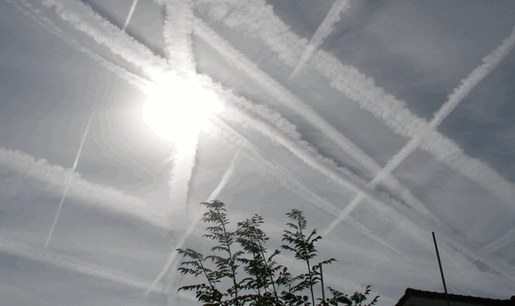

***The Budget Obama Didn’t Want You To Know About***

**Geoengineering** has now been defined as: “**the deliberate large-scale manipulation of the planetary environment** to counteract [**anthropogenic**](http://en.wikipedia.org/wiki/Anthropogenic) **climate change**.” – [***The Royal Society 2009***](http://royalsociety.org/Geoengineering-the-climate/)

Recently, the question has been asked, [What In the World Are They Spraying?](http://www.youtube.com/watch?v=te_FOsKL_5Q) The documentary with the same name answers many of those questions. The question the world is now asking is **“Who in the World Is Spraying Us?”**

**The World is Now Demanding Answers and Accountability…**

***As an introduction to this article, we will first cover information to familiarize the uninformed readers as to the core facts and information so that a more complete understanding is possible, given this complex issue.***

A [recent report](http://www.youtube.com/watch?v=4o4NNLN_BpU&feature=player_embedded) by [CBS Atlanta](http://www.cbsatlanta.com/index.html) detailed how some local citizens are outraged that such “crimes against humanity” are being carried out right before our eyes in secret.

In the report [Sen. Johnny Isakson](http://isakson.senate.gov/) was interviewed on the subject of chemtrails saying quote***:***

***“That is a theory that some people have, but there is no evidence this is happening. This is not happening.”***

It looks as if members of the government’s upper echelon and even members of the Senate will go to extreme lengths to suppress this vital information from reaching the American people.

Not to mention they signed off on the multi-billion dollar per year budgets in an economic crisis, with little to no transparency to the public.

In regards to aerosol spraying into the earth’s atmosphere, a recent update to data assembled by [**The Carnicom Institute**](http://carnicominstitute.org/) reveals the chemicals used and their respective levels of concentration. The toxic levels that are being used in these aerosols goes beyond shocking – it would appear that these levels are indeed criminal by [**EPA Standards**](http://www.epa.gov/air/airpollutants.html).

[**An Updated Look at Aerosol Toxins – Part 1**](http://carnicominstitute.org/perlingieri.html?reload)  
*By* ***Dr. Ilya Sandra Perlingieri –***  
*Copyright © 2011 – All Rights Reserved*  
*February 3, 2011*

***(Excerpt from Report)***

A new preliminary draft report by **ArizonaSkyWatch** shows dramatic increases in heavy metals that simply do not belong in our air. NOTE: The level of Manganese is so shockingly high that **ArizonaSkyWatch** also included additional information about it (see below). This report will be posted online shortly.

***This is only a preliminary overview of Arizona Air Particulates.***

2010 Air Particulates  
**These figures indicate how many times they are** **over the allowable** **toxic limit:**

**Aluminum:** **15.8**

**Antimony:** **63.3**

[Arsenic](http://en.wikipedia.org/wiki/Arsenic)**:** **418**

Barium: 5.3

Cadmium: 6.0

Chromium: 6.4

Copper: 9.0

**Iron:** **43.5**

**Lead:** **15.7**

**Manganese:** **513.8**

Nickel: 10.7

Zinc: 7.5

Additional Research & Videos are at the [**CaliforniaSkyWatch.com**](http://www.californiaskywatch.com/index.html) & the[**AgricultureDefenseCoalition.org**](http://agriculturedefensecoalition.org/).

Interestingly enough, [Monsanto](http://www.sourcewatch.org/index.php?title=Monsanto) has just released an [**Aluminum Resistant Seed**](http://www.ifpri.org/publication/delivering-genetically-engineered-crops-poor-farmers) which is[**Genetically Modified to tolerate Aluminum**](http://farmwars.info/?p=2927) in high levels in the soil. Is this a coincidence, or do they know something?

***“Control oil and you control nations;*** ***control food and you control the people.” –*** *Henry Kissinger*

See also: [**Henry Kissinger National Security Study Memorandum 200**](http://en.wikipedia.org/wiki/National_Security_Study_Memorandum_200)

***“The common enemy of humanity is man. In searching for a new enemy to unite us, we came up with the idea that pollution, the threat of global warming, water shortages, famine and the like would fit the bill. All these dangers are caused by human intervention, and it is only through changed attitudes and behavior that they can be overcome. The real enemy then, is humanity itself.”*** *–* *Richard Haass- Club of Rome*

*Another famous quote;*

***When the people fear their government, there is tyranny; when the government fears the people, there is liberty. Whenever the people are well-informed, they can be trusted with their own government.*** *-* *Thomas Jefferson*

**LINKS FOR CURRENT SOURCES**

[**David Keith GeoEngineering**](http://www.google.com/search?q=david+keith+geoengineering)

[**Fund for Innovative Climate and Energy Research (FICER)**](http://people.ucalgary.ca/%7Ekeith/FICER.html)

***Purpose***

The **Fund for Innovative Climate and Energy Research** **(FICER)** exists to accelerate the innovative development and evaluation of science and technology to address carbon dioxide and other greenhouse gas emissions and their environmental consequences. The non-profit research fund focuses on early-stage innovative research where relatively small and timely grants can significantly advance understanding, especially of the viability and scalability of proposals to address global warming.

Funded research projects are intended to produce peer-reviewed scholarly articles in recognized professional scientific and technical journals. Any intellectual property that may be generated in the course of such research resides with the researchers or their institutions.

***Grants for research are provided to the University of Calgary from gifts made by******Mr. Bill Gates******from his personal funds.***

The activities of the Fund for Innovative Climate and Energy Research fall outside the scope of activities of the Bill & Melinda Gates Foundation. FICER is not a Foundation project and has no relationship with it.

The fund has supported research in a wide range of areas. Some examples include:

• understanding carbon dioxide emissions associated with international trade in goods and services;

• developing technologies to capture carbon dioxide out of the air; and

• climate modeling to understand possible environmental consequences of solar radiation management.

*Image: Lawrence Livermore National Library*

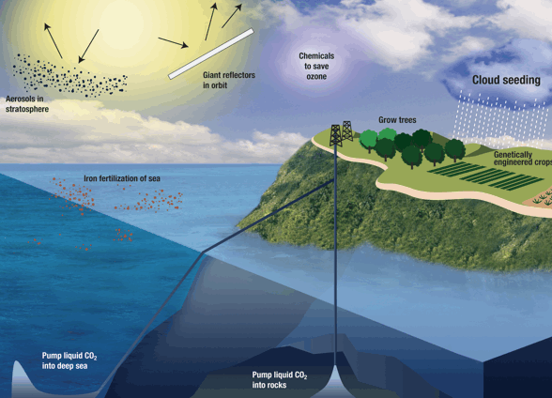

**Report On Geo-Engineering**

A select group of diabolic oligarch globalists and their puppet cronies embedded within the United States government are now involved in what some would say are crimes against humanity. These tyrants will stop at nothing to usher their hush, hush global aerosol agenda into full swing.

According to a report prepared for the Air Force titled “[Weather as a Force Multiplier: Owning the WeatherBy 2025](http://theintelhubradio.com/wp-content/uploads/2011/02/Weather-As-a-Force-Multiplier-.pdf)” the U.S. Air Force wants to fully control the weather on earth by the year 2025.

Far surpassing even the most horrific act of terror (real or staged), posing as literal gods, these globalists will stop at nothing to control the world by not only controlling the fraudulent banking systems but by owning the weather through a process (blanket term) called **Geoengineering**.

According to globalist sponsored reports, our planet is in a constant state of threat and is being bombarded with radioactive solar rays increasing planetary temperatures due to human carbon emissions. However, vast bodies of research now show that that is not the case and that global warming is another globalist myth, a ponzi scheme to collect a **Carbon Tax** worldwide, benefitting the very same group behind the curtain.

The myth the global warming “Carbon Tax” pushers have been spouting apparently can only be fixed by spraying deadly toxins in an aerosol particulate form into the earths atmosphere via large sprayer converted aircraft specifically assigned to perform Geoengineering tasks.

**Aerosol** sprays (slang: Chemtrails) are filled with a variety of chemical and metal compounds and are known to be very hazardous to human, plant, and animal health worldwide. **This danger to plant and human and animal health has been documented in films such as “What In the World Are They Spraying” by Michael Murphy & G. Edward Griffin, who have also appeared on the Intel Hub Radio Show with Shepard Ambellas**.

Ultimately, this issue was originally a matter for the EPA to rule over considering that they have the authority to sanction geoengineering activities under the National Environmental Policy ACT of 1969. However, documents such as the report to the chairman, **Committee of Science and Technology**, House of Representatives – “**Climate Change**” – Sept. 2010, U.S. Gov. Accountability Office which was submitted to all members of congress in 2010 attempt to put control into the hands of even a smaller group of people.

This report clearly is slanted and leans to take control away from the EPA along with other regulatory provisions such as; the Endangered Species ACT, and the Conformity Provision in the Clean Air ACT – total Geoengineering dis-info submitted to members of the Congress and other government branches alike.

***ClickTo Enlarge PDF***

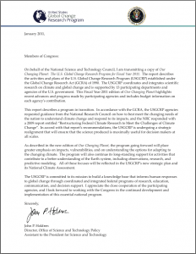

The source of most of the dis-info is Obama’s White House Science Czar John P. Holdren. The following was written on USGCRP letterhead;

“January 2011,

Members of Congress:

On behalf of the National Science and Technology Council, I am transmitting a copy of [Our Changing Planet: The U.S. Global Change Research Program for Fi...](http://downloads.globalchange.gov/ocp/ocp2011/ocp2011.pdf). The report describes the activities and plans of the U.S. Global Change Research Program (USGCRP) established under the Global Change Research Act (GCRA) of 1990. The USGCRP coordinates and integrates scientific research on climate and global change and is supported by 13 participating departments and agencies of the U.S. government. This Fiscal Year 2011 edition of Our Changing Planet highlights recent advances and progress made by participating agencies and includes budget information on each agency’s contribution.

This report describes a program in transition. In accordance with the GCRA, the USGCRP agencies requested guidance from the National Research Council on how to best meet the changing needs of the nation to understand climate change and respond to its impacts, and the NRC responded with a 2009 report entitled “Restructuring Federal Climate Research to Meet the Challenges of Climate Change”. In accord with that report’s recommendations, the USGCRP is undergoing a strategic realignment that will ensure that the science produced is maximally useful for decision makers at all scales. As described in the new edition of Our Changing Planet, the program going forward will place greater emphasis on impacts, vulnerabilities, and on understanding the options for adapting to the changing climate. The program will also continue its long-standing support for activities that contribute to a better understanding of the Earth system, including observations, research, and predictive modeling.

All of these focuses will be reflected in the USGCRP’s new strategic plan and its National Climate Assessment.

The USGCRP is committed to its mission to build a knowledge base that informs human responses to global change through coordinated and integrated federal programs of research, education, communication, and decision support. I appreciate the close cooperation of the participating agencies, and I look forward to working with the Congress in the continued development and implementation of this essential national program.

Sincerely,

***John P. Holdren Director,*** *Office of Science and Technology Policy Assistant to the President for Science and Technology” – Our Changing Planet*

Even more disturbing then that is the fact that your so called representatives have been approving yearly geoengineering budgets in the upwards of billions of dollars per year (as outlined in the document “Our Changing Planet – The US Global Change Research Program for the Fiscal Year of 2011, which is a supplement to the Presidents Budget for 2011, much of which is unaccounted for and not even included in the budget possible signifying even a more nefarious plot involving some black budget.

Back tracking to the year 2001, President elect George W. Bush established the (CCRI) Climate Change Research Initiative. A year later it was made public that the USGCRP or United States Global Change Research program and the CCRI both would become what is known as the (CCSP) Climate Change Science Program. Now, under the Obama Administration the legacy continues to move forward as the USGCRP.

***Geoengineering Regions***

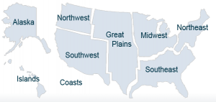

A report entitled “Global Climate Change Impacts in the United States” released in 2009, documents how the USGCRP divided the US into nine regions similar to FEMA regions. Also tucked into the report was the statement “A central finding of the report was that the vast majority of climate scientists agree that global warming is unequivocal and primarily human induced” – Source: Our Changing Planet.

The document goes on to mention the devastating effects of climate change, including the effect on crops, human health and livestock.

But the most startling fact in the document is the actual budget itself, a mere 2.7 billion for 2011 alone (not including many costs) 24% higher than 2010’s budget.

[The Global Change Research ACT of 1990, SEC. 102](http://www.globalchange.gov/about/program-structure/global-change-research-act), Committee on Earth and Environmental Sciences states;

a) ESTABLISHMENT.–The President, through the Council, shall establish a Committee on Earth and Environmental Sciences. The Committee shall carry out Council functions under section 401 of the National Science and Technology Policy, Organization, and Priorities Act of 1976 (42 U.S.C. 6651) relating to global change research, for the purpose of increasing the overall effectiveness and productivity of Federal global change research efforts.

(b) MEMBERSHIP.–The Committee shall consist of at least one representative from–

1. the National Science Foundation;

2. the National Aeronautics and Space Administration;

3. the National Oceanic and Atmospheric Administration of the Department of Commerce;

4. the Environmental Protection Agency;

5. the Department of Energy;

6. the Department of State;

7. the Department of Defense;

8. the Department of the Interior;

9. the Department of Agriculture;

10. the Department of Transportation;

11. the Office of Management and Budget;

12. the Office of Science and Technology Policy;

13. the Council on Environmental Quality;

14. the National Institute of Environmental Health Sciences of the National Institutes of Health;

15. such other agencies and departments of the United States as the President or the Chairman of the Council considers appropriate.

Such representatives shall be high ranking officials of their agency or department, wherever possible the head of the portion of that agency or department that is most relevant to the purpose of the title described in section 101(b).

(c) CHAIRPERSON.–The Chairman of the Council, in consultation with the Committee, biennially shall select one of the Committee members to serve as Chairperson. The Chairperson shall be knowledgeable and experienced with regard to the administration of scientific research programs, and shall be a representative of an agency that contributes substantially, in terms of scientific research capability and budget, to the Program.

(d) SUPPORT PERSONNEL.–An Executive Secretary shall be appointed by the Chairperson of the

Committee, with the approval of the Committee. The Executive Secretary shall be a permanent employee of one of the agencies or departments represented on the Committee, and shall remain in the employ of such agency or department. The Chairman of the Council shall have the authority to make personnel decisions regarding any employees detailed to the Council for purposes of working on business of the Committee pursuant to section 401 of the National Science and Technology Policy, Organization, and Priorities Act of 1976 (42 U.S.C. 6651).

(e) FUNCTIONS RELATIVE TO GLOBAL CHANGE.–The Council, through the Committee, shall be responsible for planning and coordinating the Program. In carrying out this responsibility, the Committee shall–

1. serve as the forum for developing the Plan and for overseeing its implementation;

2. improve cooperation among Federal agencies and departments with respect to global change research activities;

3. provide budgetary advice as specified in section 105;

4. work with academic, State, industry, and other groups conducting global change research, to

provide for periodic public and peer review of the Program;

5. cooperate with the Secretary of State in– (A) providing representation at international meetings and conferences on global change research in which the United States participates; and

(B) coordinating the Federal activities of the United States with programs of other nations and with international global change research activities such as the International Geosphere-Biosphere Program;

6. consult with actual and potential users of the results of the Program to ensure that such results are useful in developing national and international policy responses to global change; and

7. report at least annually to the President and the Congress, through the Chairman of the Council, on Federal global change research priorities, policies, and programs.”

The following is a list of the members included in the Subcommittee on Global Change Research;

**SUBCOMMITTEE ON GLOBAL CHANGE RESEARCH**

***Made up of the following members:***

Thomas Karl -Department of Commerce Chair

Thomas Armstrong - Department of the Interior Vice Chair, Adaptation Research

Mike Freilich - National Aeronautics and Space Administration Vice Chair, Integrated Observations

Timothy Killeen - National Science Foundation Vice Chair, Strategic Planning

William Breed -U.S. Agency for International Development

John Balbus - Department of Health and Human Services

William Hohenstein - Department of Agriculture

Jack Kaye - National Aeronautics and Space Administration

Chester Koblinsky - Department of Commerce

Linda Lawson - Department of Transportation

Leonard Hirsch - Smithsonian Institution

Anna Palmisano - Department of Energy

A description of the subcommittee on (p.2) Our Changing Planet Reads;

*“The* [*USGCRP*](http://www.globalchange.gov/) *is directed by the Subcommittee for Global Change Research (SGCR), which falls under the National Science and Technology Council. The SGCR comprises representatives from 13 departments and agencies and is led by a Chair from one of the participating agencies (currently from the Department of Commerce, National Oceanic and Atmospheric Administration [NOAA]). In order to align the program’s governance with the needs, Vice- Chairs have been identified for Strategic Planning, Integrated Observations, and Adaptation Research. Additional vice-chairs will be identified as needed. The program is supported by the USGCRP Integration and Coordination Office and conducts many of its activities through interagency working groups that plan and implement research and crosscutting activities, such as communications, decision support, and information and data concerns. The Office of Science and Technology Policy (OSTP) and Office of Management and Budget (OMB) work closely with the SGCR, the Integration and Coordination Office, and the interagency working groups to establish research priorities and funding plans to ensure that the program is aligned with national priorities, reflects agency planning, and meets the requirements of the GCRA. “*

The Subcommittee in question has now supplied the President with a supplement to the fiscal budget for 2011, which was presented to members of congress in January of 2011 on behalf of the National Science and Technology Policy – Assistant to the President for Science and Technology, John P. Holdren.

The ([USGCRP](http://www.globalchange.gov/)) brings together a total of 13 different agencies and merges them into one single agency program that has been in the works science 1988 or prior.

In 1990 the USGCRP received generous congressional support under (GCRA P.L. 101-606). It is no mystery that aerosol spraying operations have been ongoing since the early 1990’s. Prior to 1990 one could enjoy a true clear blue sky, a figment of the past in 2011 – where none are to be found.

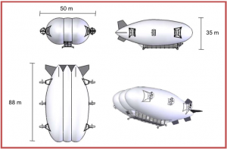

***Airship Proposed for Chemtrail Spraying***

So just how deep does the geoengineering/terraforming rabbit hole go? [The Intel Hub](http://www.theintelhub.com/)was able to obtain a copy of the final report prepared by the University of Calgary under contract by Aurora Flight Sciences titled “Geoengineering cost analysis”. In the report there is smoking gun evidence of the entire geoengineering saga from the secret bases, to the payload, to what type of aircraft or “airship” will be the most cost effective to spread toxic particulates throughout the earths atmosphere. The final report also included budgets for different applications for aerosol dispersal within the atmosphere.

*“Existing aircraft are evaluated based on cost of acquisition and operations. An in-depth new aircraft design study and cost analysis was conducted to determine the cost of developing and operating a dedicated geoengineering airplane type. Similarly, an airship design study and cost analysis was conducted. Finally a survey of non-aircraft systems was conducted to determine how their costs compare to aircraft and airships.*

*Yearly costs of 1M tonne geoengineering operations for all the systems examined are presented in Figure 2. Some systems are easily written off due to extremely high costs. Rocket based systems are not cost competitive due to the large number of launches required and the impact of occasional rocket failures on required fleet size. A system based on 16Σ” naval Mark 7 guns was analyzed and compared to previous work by the National Research Council.4 This system requires large numbers of shots increasing projectile costs and driving yearly costs over $100B. Gun costs become more competitive if the projectile payload fraction can be increased from about 10% for a standard shell to 50%. With this and a few improvements over the 1940-era Mark 7 gun yearly costs are still in the $20B range….The primary vehicles examined to lift particulate to stratospheric altitudes and disperse them at a predetermined release rate are airplanes and airships; rockets and other non- aircraft methods such as guns and suspended pipes are also surveyed.” –*[*Aurora Flight Sciences: Geoengineering Final Report*](http://theintelhubradio.com/wp-content/uploads/2011/02/AuroraGeoReport.pdf) *(p.5)*

*“Geoengineering may provide a means to create a time buffer against catastrophic cli- mate change while long-term emissions reduction actions take effect. One approach is to disperse sulfur compounds at high altitude to reduce the effective solar flux entering the atmosphere. This report will evaluate the means of delivering sufficient mass of this or similar material to affect climate change on a global scale. The goal of this study is to use engineering design and cost analysis to determine the feasibility and cost of a delivering material to the stratosphere for solar radiation management (SRM).* ***This study does notexamine effectiveness or risks of injecting material into the stratosphere for SRM.*** *Its goal is simply to compare a range of delivery systems on a single cost basis.” –* [*Aurora Flight Sciences: Geoengineering Final Report*](http://theintelhubradio.com/wp-content/uploads/2011/02/AuroraGeoReport.pdf) *(p.6)*

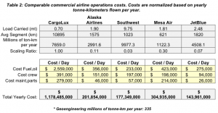

***Operational Costs – Not Including Payload***

*The* [report](http://theintelhubradio.com/wp-content/uploads/2011/02/AuroraGeoReport.pdf) mentions how payload costs are not included in the estimate nor are the base/facility costs and continues on (p.8) to say;

*“This study focuses on airplane and airship operations to the stratosphere to release a geoengineering payload with the goal of reducing incoming solar flux. Airships are also considered for this mission. To provide a comparison to conventional aircraft operations, more exotic concepts such as rockets, guns, and suspended pipes are also examined….For maximum cooling impact, the particulate payloads are best placed near the equator. This study assumes that the payload is released within latitudes 30°N and 30°S, though North-South basing location had minimal effect on cost. Transit operations, flying East- West between equally spaced bases around the equator, were examined as a method to ensure adequate dispersal of the payload around the equator.*

*Global winds aid in East-West dispersal so a smaller number of bases and shorter range systems (referred to as Regional operations) can be employed with minimal impact on dispersal. Region- al operations allow the dispersal leg length to be dictated by the desired release rate of 0.03kg/m flown. This means the airplanes fly no further than they have to, on the order of 300-800 km, and fuel costs are minimized.” – Aurora Flight Sciences: Geoengineering Final report Yearly cost estimates from different dispersal methods ranged from over 1 billion dollars a year all the way up to rocket dispersed aerosol in the upper atmosphere at the cost of over 100 billion dollars per year.*

***GeoEngineering Research 2011***

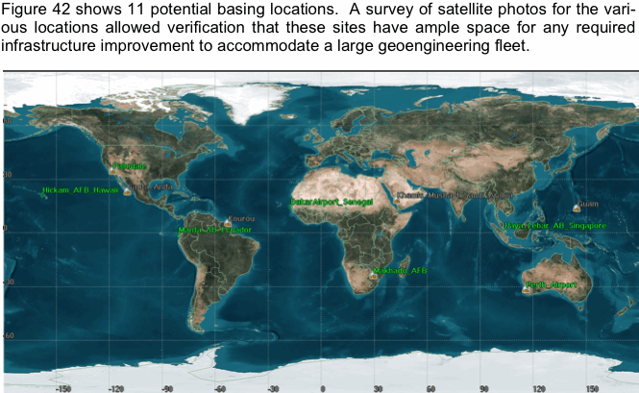

[California SkyWatch](http://www.californiaskywatch.com/)

[Agriculture Defense Coalition](http://agriculturedefensecoalition.org/)

[**GeoEngineering Watch**](http://www.geoengineeringwatch.org/)

[Arizona SkyWatch](http://arizonaskywatch.com/)

[**Henry Kissinger’s 1974 Plan for Food Control Genocide**](http://www.schillerinstitute.org/food_for_peace/kiss_nssm_jb_1995.html)

[**Food Sovereignty**](http://en.wikipedia.org/wiki/Food_sovereignty)

*Today Americans would be outraged if U.N. troops entered Los Angeles to restore order; tomorrow they will be grateful! This is especially true if they were told there was an outside threat from beyond whether real or promulgated, that threatened our very existence. It is then that all peoples of the world will pledge with world leaders to deliver them from this evil. The one thing every man fears is the unknown. When presented with this scenario, individual rights will be willingly relinquished for the guarantee of their well being granted to them by their world government.” –* **Henry Kissinger in an address to the Bilderbergers at Evian, France, May 21, 1992.**

**Note:** *Websites/News Agencies are welcome to post 50% of this article linking back to us. Or contact us to post in full.*

***UPDATE – March 31st, 2011***

• Aluminum resistant gene patent # 7582809

• Patent granted on September 1, 2009

• Patent developed at the Robert W. Holley Center for Agricultural Health at Cornell University in Ithaca, NY.

• Leon Kochian and Jurandir Vieira de Magallhaes are the primary inventors/ researchers

• Patent assigned to US Department of Agriculture and Brazilian Enterprise for Agricultural Research

• According to Cornell University Chronicle Online, the research project was supported in part by the McKnight Foundation Collaborative Crop Research Program, the Generation Challenge Program, the National Science Foundation and the USDA.

The Bill and Melinda Gates Foundation is a contributor to both the McKnight Foundation and the Generation Challenge Program.

<http://www.mcknight.org/international/cropresearch.aspx>

[http://www.gatesfoundation.org/press-releases/Pages/molecular-breed...](http://www.gatesfoundation.org/press-releases/Pages/molecular-breeding-platform-aims-to-enhance-plant-breeding-090901.aspx)

Hundreds of Rain and Snow Tests HAVE BEEN DONE!

<http://www.geoengineeringwatch.org/htm/tests.html>

Tags: [Billions](http://chemtruth.ning.com/forum/topic/listForTag?tag=Billions), [Budget](http://chemtruth.ning.com/forum/topic/listForTag?tag=Budget), [Chemtrail](http://chemtruth.ning.com/forum/topic/listForTag?tag=Chemtrail), [Congress](http://chemtruth.ning.com/forum/topic/listForTag?tag=Congress), [Exceeds](http://chemtruth.ning.com/forum/topic/listForTag?tag=Exceeds), [Presidential](http://chemtruth.ning.com/forum/topic/listForTag?tag=Presidential), [Secret](http://chemtruth.ning.com/forum/topic/listForTag?tag=Secret), [Uncovered](http://chemtruth.ning.com/forum/topic/listForTag?tag=Uncovered), [chemtrails](http://chemtruth.ning.com/forum/topic/listForTag?tag=chemtrails), [geoengineering](http://chemtruth.ning.com/forum/topic/listForTag?tag=geoengineering)